LOW CODE APPLICATION DEVELOPMENT USING ZOHO CREATOR

NAME:DIVYA S
ROLL NO:240701128

EXPERIMENT:1
COMPARATIVE STUDY OF LOW-CODE DEVELOPMENT VERSUS TRADITIONAL APPLICATION DEVELOPMENT APPROACHES

Aim
The main aim of this study is to compare Traditional Application Development and Low-Code Development based on their development process, cost, time, flexibility, scalability, maintenance, and overall efficiency. The study helps understand how low-code platforms are transforming software development while identifying situations where traditional development remains the preferred choice.
Objectives:
- To understand the concept of traditional application development.
- To study the fundamentals of low-code development.
- To compare both approaches based on various parameters.
- To identify the advantages and limitations of each approach.
- To determine suitable use cases for both development methods.

Introduction to Traditional Application Development
Traditional application development is the conventional method of building software applications by writing source code manually using programming languages such as Java, Python, C#, PHP, JavaScript, or C++.
In this approach, developers are responsible for designing, coding, testing, debugging, deploying, and maintaining the application. Every feature is developed from scratch, giving developers complete control over the application's architecture and functionality.
Traditional development follows Software Development Life Cycle (SDLC) methodologies such as:
- Waterfall Model
- Agile Model
- Spiral Model
- DevOps

Features
- Manual coding
- High customization
- Full control over application architecture
- Suitable for large-scale enterprise applications
- Requires skilled programmers

Advantages
- High flexibility
- Better performance optimization
- Strong security implementation
- Unlimited customization
- Suitable for complex applications

Disadvantages
- Longer development time
- Higher development cost
- Requires experienced developers
- Complex maintenance
- Slower deployment

Introduction to Low-Code Development
Low-code development is a modern software development approach that enables developers to create applications with minimal hand coding by using drag-and-drop components, visual interfaces, reusable templates, and automated workflows.
Instead of writing thousands of lines of code, developers build applications using graphical tools while adding custom code only when required.
Popular low-code platforms include:
- Microsoft Power Apps
- OutSystems
- Mendix
- Appian
- Zoho Creator

Features
- Visual development environment
- Drag-and-drop interface
- Pre-built templates
- Automated workflows
- Rapid deployment

Advantages
- Faster application development
- Lower development cost
- Minimal coding knowledge required
- Easy maintenance
- Faster updates and deployment

Disadvantages
- Limited customization
- Vendor dependency
- Licensing costs
- Less control over underlying code
- May not suit highly complex applications

Diagram for Stages in Traditional and Low-Code Development

Traditional Development Process:
- Requirement Analysis
- System Design
- Manual Coding (Development)
- Testing
- Debugging
- Deployment
- Maintenance

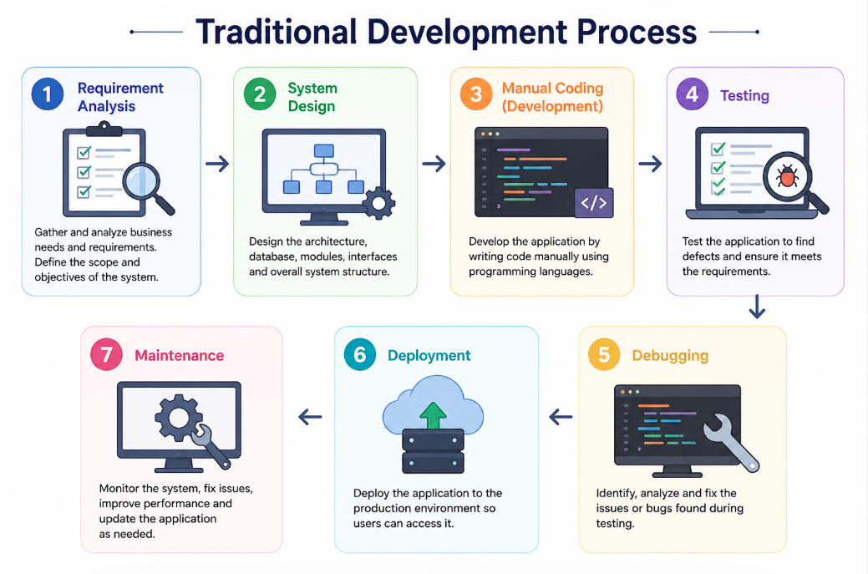

Low-Code Development Process:
- Requirement Analysis
- Visual Application Design
- Component Configuration
- Workflow & Logic Configuration
- Minimal Custom Coding (Optional)
- Testing & Validation
- One-Click Deployment
- Maintenance & Updates

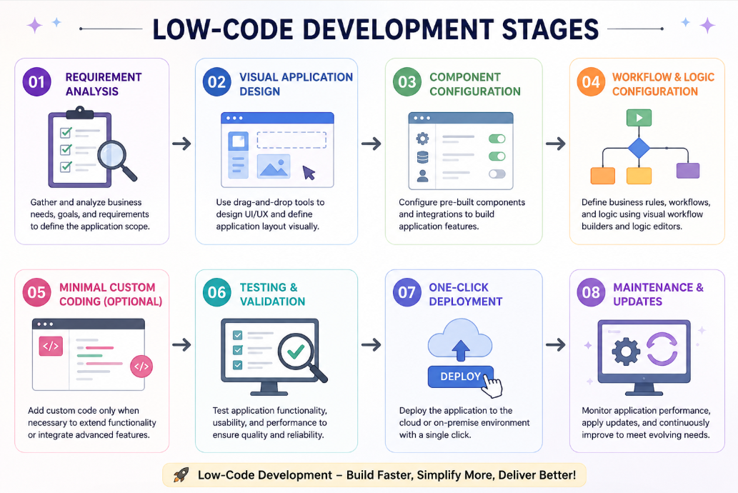

Comparison Of Traditional And Low Code Development

Feature | Traditional Development | Low-Code Development
Development Speed | Slower due to manual coding | Faster using drag-and-drop components
Coding Requirement | Requires extensive programming | Requires little or no coding
Development Cost | Higher due to skilled developers and longer timelines | Lower due to reduced development effort
Technical Expertise | High programming knowledge required | Can be used by both developers and citizen developers
Customization | Highly flexible with unlimited customization | Limited to platform capabilities (custom code optional)
Development Time | Weeks to months | Days to weeks
Maintenance | Manual updates and code maintenance | Easier updates through the platform
Testing | Manual and code-intensive testing | Built-in testing and validation tools
Deployment | Manual deployment process | One-click or automated deployment
Scalability | Highly scalable with custom architecture | Scalable depending on platform features
Integration | Requires custom APIs and coding | Pre-built connectors and integrations
Best Suited For | Complex, enterprise-level applications | Rapid application development, prototypes, business apps

Result
The comparative study concludes that Low-Code Development enables faster, cost-effective, and easier application development with minimal coding, making it ideal for rapid business applications and prototypes. Traditional Application Development provides greater flexibility, customization, and control, making it more suitable for complex, large-scale enterprise applications.

